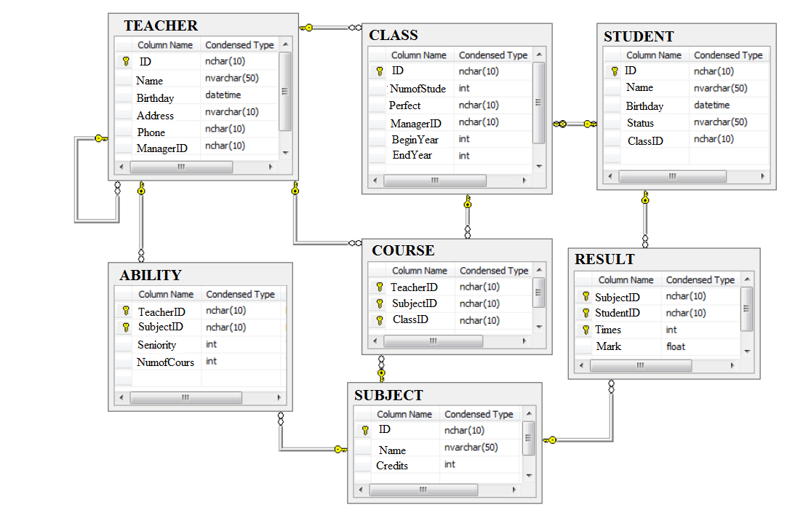

Example:

1. List the teachers born in 1992 who have been assigned to manage the class.

Select t.*

From teacher t, class c

Where Year (t.birday)=1992 and t.ID=c.ManagerID

1. List the teachers born in 1992 who were never assigned to manage the class.

Select t.*

From teacher t

Where Year (t.birday)=1992 and t.ID not in (

select c.managerID from Class c)

1. List the perfect for class ending in 2015.

Select t.*

From Class c, Student t

Where c.endyear=2015 and c.perfect=t.ID

1. Count the times that the teacher “nguyen van an” was assigned to teach the class ‘LH0004’

Select count(*) as ‘SL’

From teacher t, Course c

Where t.name=’Nguyen Van An’ and c.teacherID=t.ID and c.classID=’LH0004’

1. List the students who passed ‘Computer Network’

Select s.*

From subject su , Result r, student s

Where su.Name=‘Computer Network’ and r.subjectID=su.ID and r.studentID=s.ID and r.mark>=5

and **r.times >= all ( select r1.times**

**from result r1 where r1.studentID= r.studentID and**

**r1.subjectID= r.subjectID)**

1. For each subject, indicate the number of students who has passed it.

Select su.Name, count(*) as ‘SL’

From Result r, student s, subject su

Where r.studentID=s.ID and s.subjectID=su.ID

and r.mark>=5 and **r.times >= all ( select r1.times**

**from result r1 where r1.studentID= r.studentID and**

**r1.subjectID= r.subjectID)**

group by su.ID, su.Name

1. List subject that more than four students passed.

Select su.Name, count(*) as ‘SL’

From Result r, student s, subject su

Where r.studentID=s.ID and s.subjectID=su.ID

and r.mark>=5 and r.times >= all ( select r1.times

from result r1 where r1.studentID= r.studentID and

r1.subjectID= r.subjectID)

group by su.ID, su.Name

having count(*) > 4

1. List the teachers assigned to teach "Data Mining".
2. List the name of the subjects that the teacher named "Nhan Lan" was
3. Show how many students have passed "Basic Informatics".
4. List the subjects that the student named "Kieu" studies in
5. List the teachers who are managed by another teacher. Provide the information including the teacher name and the manager name.
6. Provide information about students who have taken the most mark in 'Computer Networks'

14. Provide information about students who have pass the most number of subjects.

1. Indicate the GPA of the student ‘Nguyen Van An’

-